**1. Pull file from git hub repository to the system local folder.**

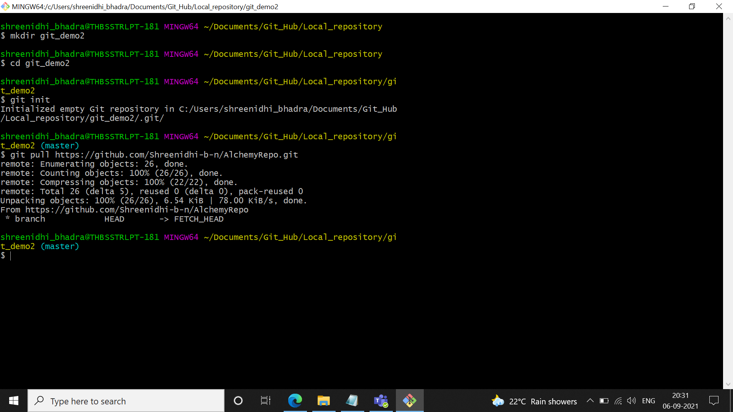

**2. Push file from system local folder to git hub repository.**

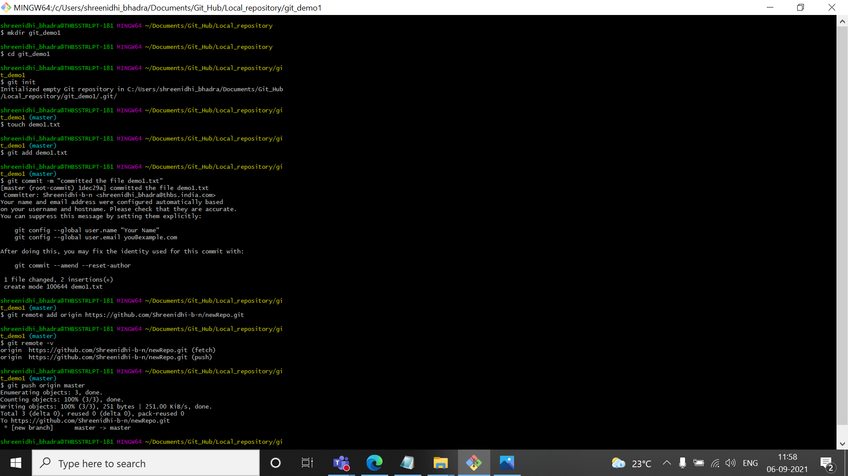

**3. Push file from system local folder to git hub repository.**

